System Manual

Group 4: Ball Buddy

## 

## 

## 

## 

## 

Mentor:

Professor Klinkhachorn

Group Members:

Abdulhadi Altamaimi, Zachary Chaffin, Hyejun Park, Christopher Sydnor, Bryce Vida

## Abstract

Ball Buddy is a ball robot designed primarily to assist elderly users in some of their daily activities. Ball Buddy is a platform to expand upon, as the simple design allows for easy adjustment of current parts and additions to be introduced. Ball Buddy currently maneuvers throughout most environments with relative ease. The attached head camera allows either the remote control of the robot or for remote visual of another part of the house. Ball Buddy’s simple design and control will allow for ease of use with elderly consumers and other potential buyers.

## Table of Contents

**Introduction** **3**

**Design Achievements** **4**

**Complete hardware design** **5**

**Complete Software Design** **6**

**Complete source code listing.** **7**

**Test Results** **8**

**Safety Precautions** **9**

**Reflections** **11**

**Appendix 1** **- User Manual 12**

**Appendix 2** **- Maintenance Manual 13**

## Introduction

‘Ball Buddy’ is a personal companion robot aimed at assisting elderly in day to day tasks. It is used for daily-based purposes. Ball Buddy is an excellent assistant that provides entertainment via users command. It will follow the user and spend its day with the user, comforting and sharing daily life.

Ball Buddy sports a spherical body and lightweight features. Because it uses its body as wheel and rotates 360 degrees when it turns, it can make efficient maneuvers, especially in corners or near objects. It is less likely to hit the object or user with its whole dimension and weight. Due to its lightweight form factor, it will minimize the impulse toward an object. Unlike traditional robots, this feature also allows minimal damage or scratching on walls or other objects. In addition, its cliff detection ability prevents damage to the robot and other objects that may be damaged from the robot falling down stairs.

Users will download an app via apple or android phone and control the Ball Buddy as the user wants. Ball Buddy will play music, provide a wifi hotspot and has a charging port for the user. It also contains a dancing feature, showing some of its moves such as spinning and bobbing its head.

Ball Buddy is a self-sustaining robot that provides simple and convenient service for consumers. When it reaches a low level of battery, the user is notified via a series of beeps, and can be recharged at its charging station.

## Design Achievements

* Design durable, efficient, and replaceable body panels.
* Successfully connected with bluetooth model
* Developed user-friendly and simple app to control Ball Buddy via android application
* Able to drive forward, backwards, and is able to turn left and right
* Able to send video from head which can be streamed

## Complete hardware design

Complete physical layout of all boards showing chips and locations

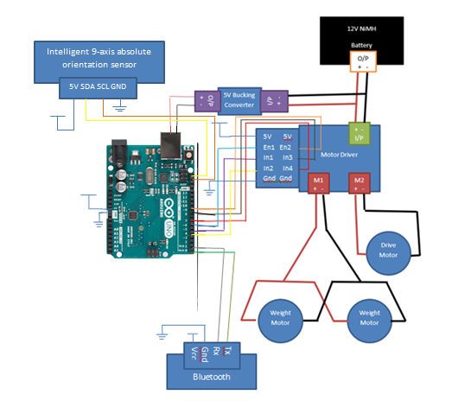

List of materials - ALL parts used with labels associated with schematics and layouts

* Arduino UNO R3
  + <https://store.arduino.cc/usa/arduino-uno-rev3>
* Handson Technology XY-160D
  + Motor Driver
* BNO055
  + Intelligent 9-axis absolute orientation sensor
  + <https://cdn-shop.adafruit.com/datasheets/BST_BNO055_DS000_12.pdf>
* Pololu D24V150F12
  + 12V to 5V Bucking Converter
  + <https://www.pololu.com/product/2885>
* 12V 3000mAh NiMH Battery
  + x2 in Parallel
  + <https://www.pitsco.com/TETRIX-12-Volt-Rechargeable-NiMH-Battery-Pack>
* HD Premium Planetary Gear Motor,
  + 118 rpm 958.2 oz-in
  + Driver Motor
  + <https://www.servocity.com/118-rpm-hd-premium-planetary-gear-motor>
* TETRIX® MAX DC Motor,
  + 152 rpm 320 oz-in
  + Weight Motors
  + <https://www.pitsco.com/TETRIX-DC-Gear-Motor>
* DSD TECH HM-10 Bluetooth 4.0 BLE iBeacon
  + <https://drive.google.com/file/d/1XJQznN6fPFQqAoTVqZh06vhbJ7eF0VFu/view>

Box containment and layouts of all parts mounted in or on the box containment.

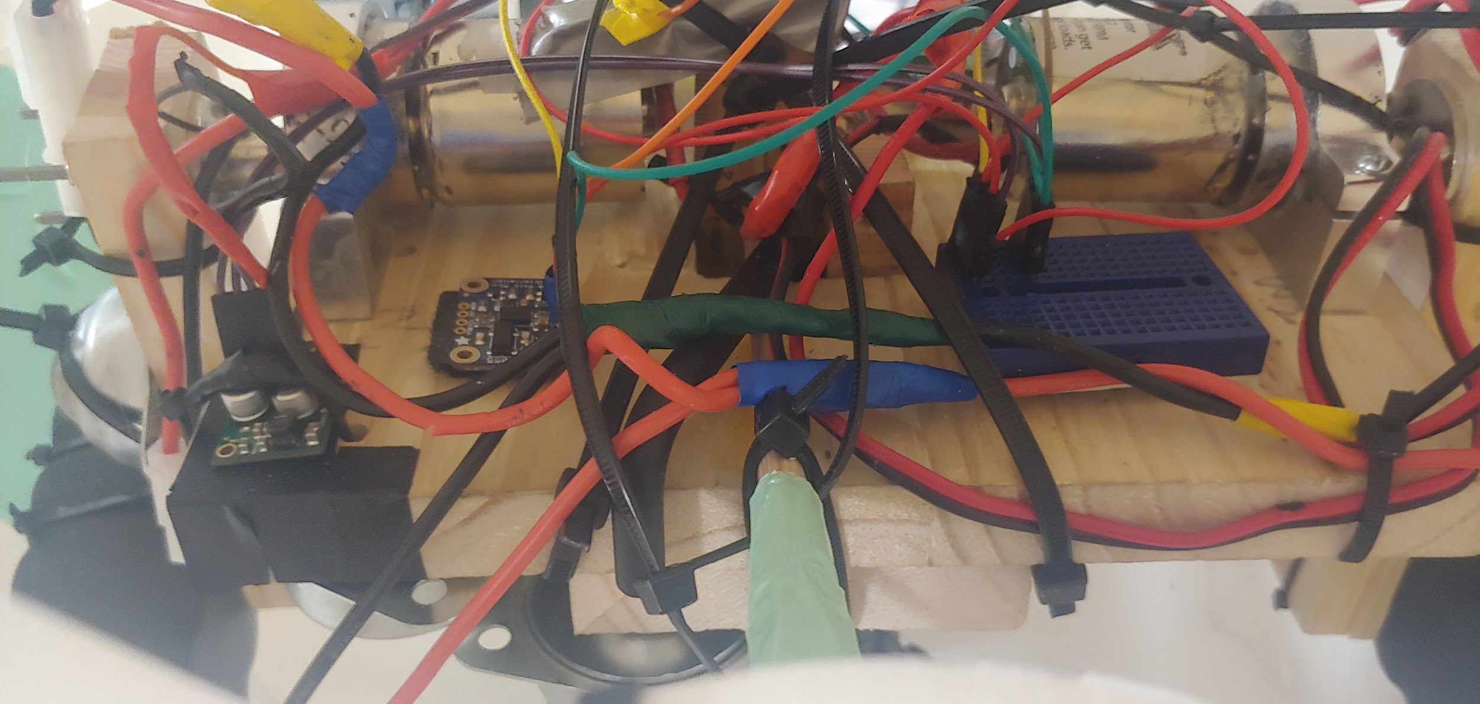

Placement of the 5V bucking converter, the 9-axis imu, and breadboard containinadboard containing 5V and Gnd

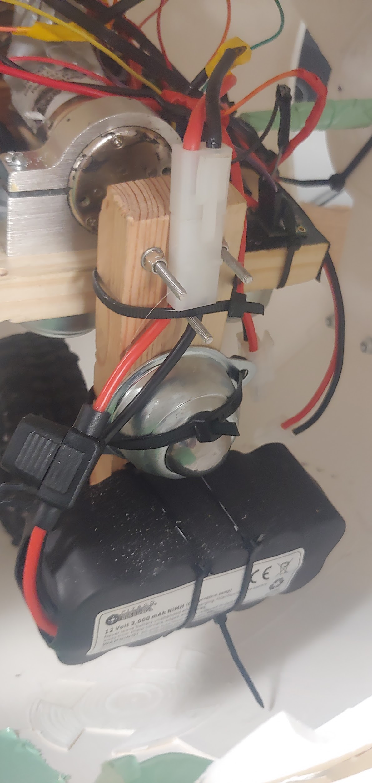

Weight Motor and Pendulum Placement

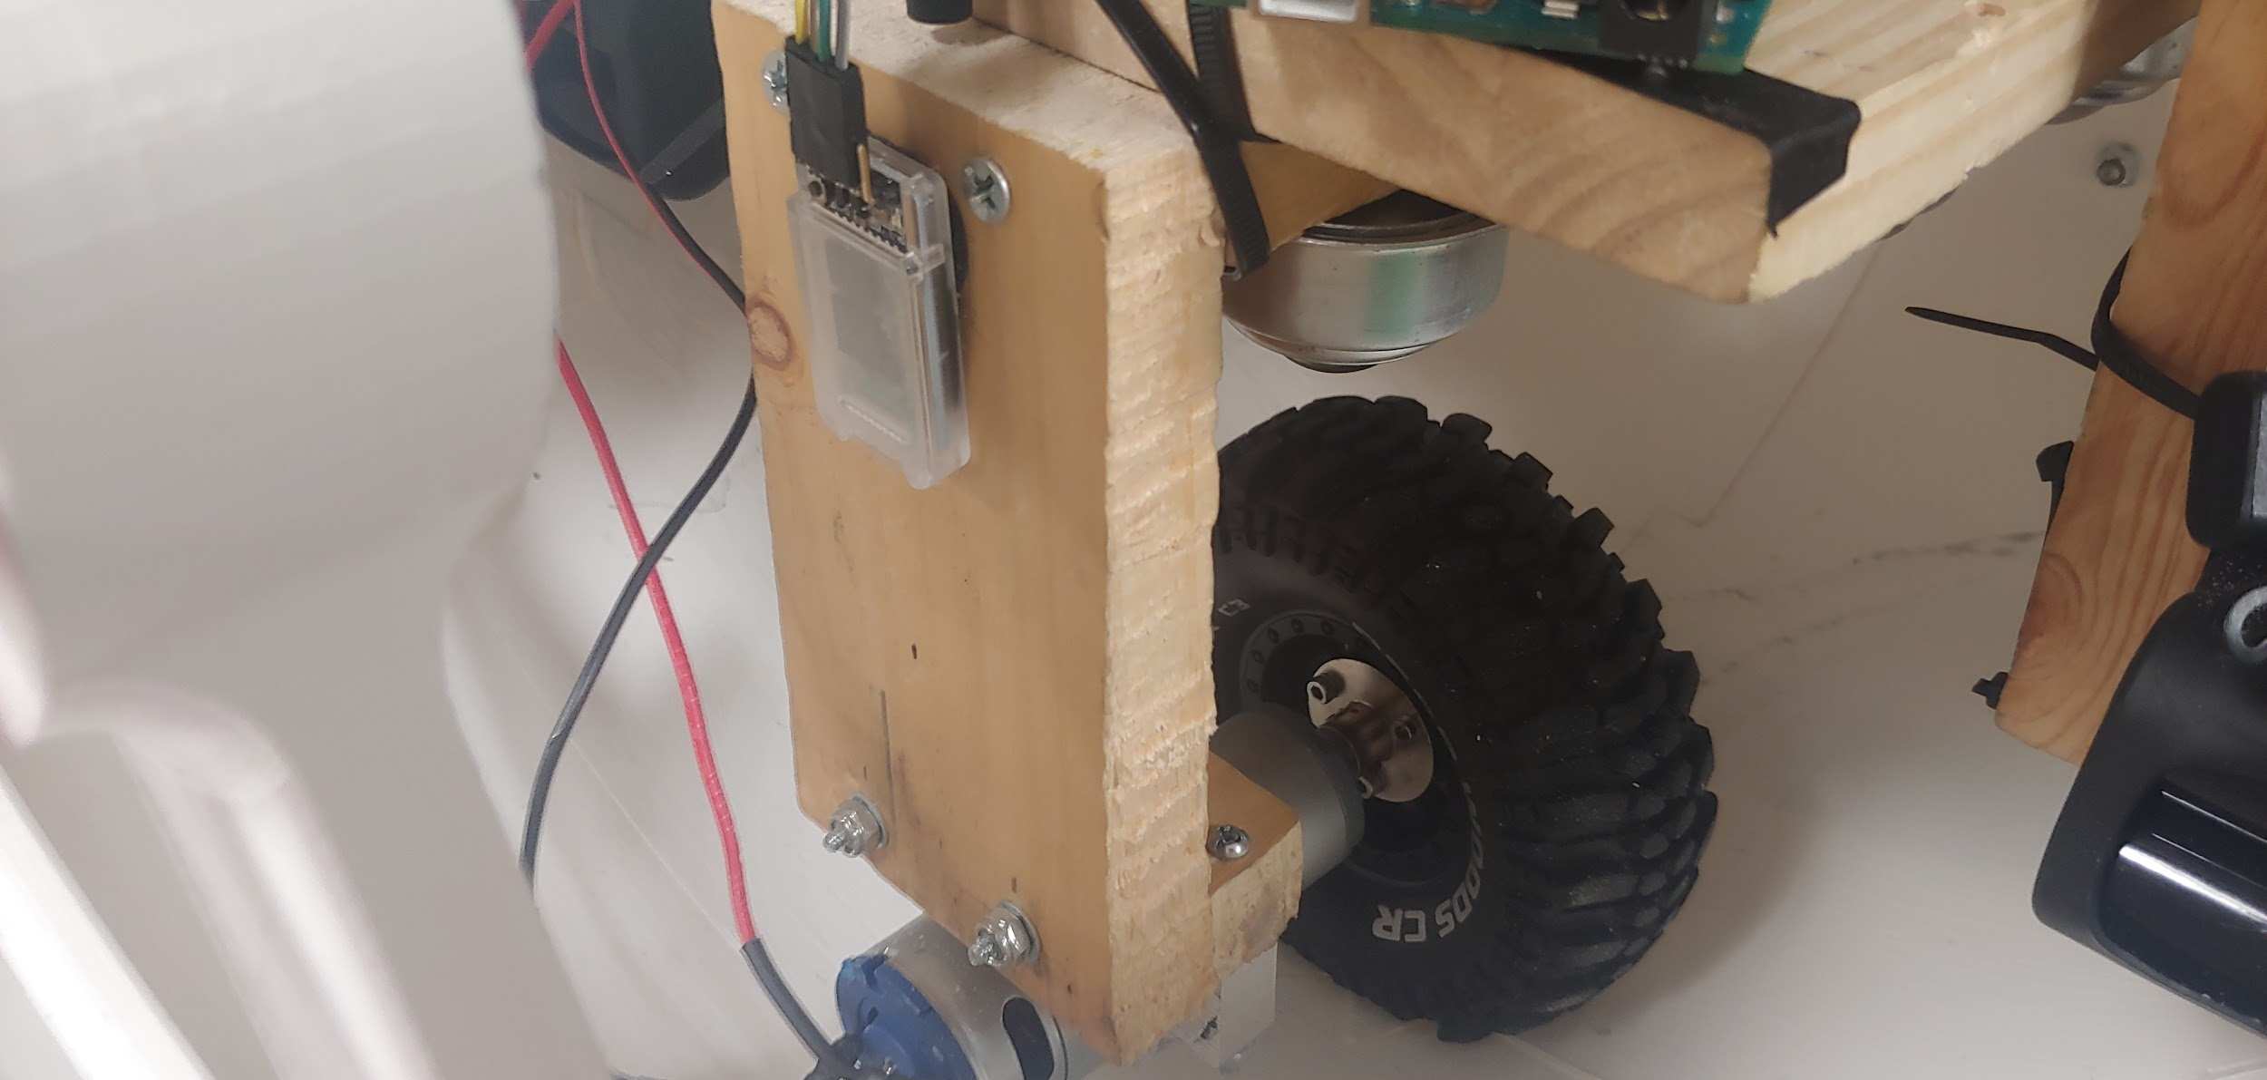

Drive Motor Placement

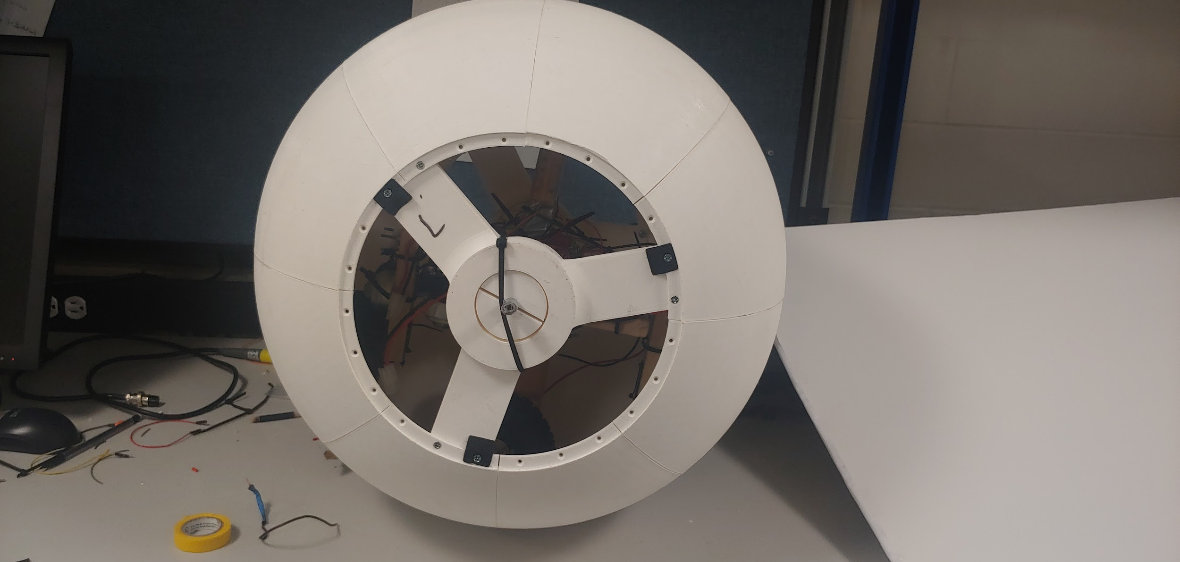

Outer Shell with panels, Y-wing, Bearing Holder.

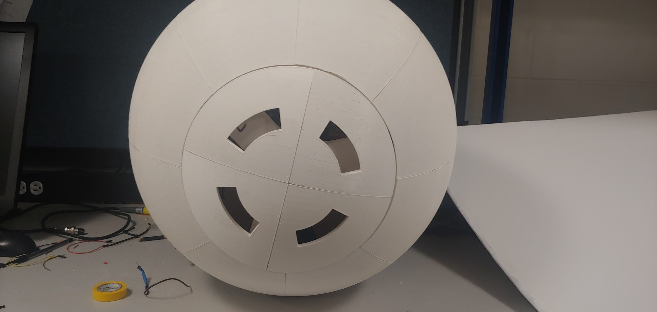

Cover Panel Placement

## Complete Software Design

Software for Ball Buddy was written in two areas. First, an app was created to connect to the ball via Bluetooth and send commands. Second, the ball’s onboard Arduino was programmed to send different instructions to the motor controller based on these Bluetooth commands. Figure 4 shows the flow of data throughout the Ball Buddy/controller app system. Due to time constraints, our group chose not to pursue hotspot and music functionality at this time, however given the appropriate hardware these features can be easily implemented alongside the existing source code and design.

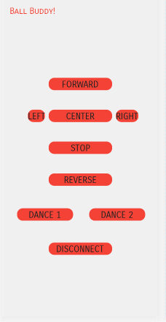

**Figure 3**: App Interface

The control app makes use of a few large, easy to click controls. The main controls for the robot’s movement are centered on the screen include forward,back, left, right, reverse, and brake controls. Dance programs are available below. The disconnect button is placed at the bottom, far away from other controls to help avoid accidental presses.

The Arduino listens for commands to be sent over bluetooth and, according to the command, sets different values to the onboard pins connected to the motor controller. The motor controller then handles the operation of the three onboard motors. This arduino code is written with testing and extension in mind - developers can easily make changes and tweaks to Ball Buddy's operation without having to modify a great deal of code. Variables are used to easily control parameters like speed and turning strength, and pin assignments are also easily changeable.

Also implemented is a PD controller, allowing Ball Buddy to use his motors autonomously in order to keep himself upright and stable, without constant input from the user.

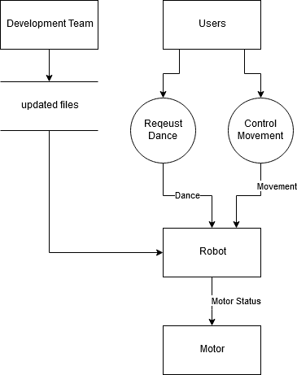

**Figure 4**: Data flow Diagram

## Complete source code listing.

(This should be on the CD as well.)

Source code written for ball buddy includes an arduino sketch, and an android studio project. Both of which may be found in the project folder.

Files of note include:

1. //arduino file name

Handles commands coming from app and translates into motor controls. Also implements PD controller

1. ledControl.java

Creates and sends commands to Ball Buddy

1. Activity_led_control.xml

Defines the layout of the app interface, and links buttons with commands to be sent

## Test Results

Testing motors, panels, bluetooth, app, head, camera, batteries,

Tests:

Testing motors functionality to check which motor works as needed.

Testing the Bluetooth to ensure connection to the app and any other Bluetooth device could be connected.

Testing the application connection to the robot and testing all buttons on the app to ensure the functions desired from each button.

Testing the head to be attached to the body, and testing the strength and balance of the head on the body/ball.

Testing the camera to ensure good connection and clear streaming of the ball’s vision.

Testing the battery functionality and check on power level, and the weight of each battery, since the batteries are used for tilting mechanism, or the ones used for the head which could cause overweight and detach the head.

Testing the ball design rolling forward and backward, turning right and left, and standing still and balancing on it’s own.

Results:

The robot successfully moved forward and backward, right and left, which means the app successfully connects to the robot via Bluetooth and controlling it, the design was strong enough to bear all the weight, and the motors are doing their job as expected. The batteries provides enough power and the weights are suitable to balance the ball.

The head is attached and balanced while moving the robot, and the camera can stream perfectly, the battery powering the camera weighs enough to keep the head moving and holding on the body of the bot.

## Safety Precautions

There are several safety-related precautions to be aware of when handling Ball Buddy and when attempting to make any adjustments to the hardware. These precautions may not be particularly life-threatening to most individuals but adhering to them is recommended to avoid unnecessary damages to either the user or to Ball Buddy itself.

1. Ball Buddy is fairly heavy due to the need to maintain friction so as to keep the robot moving. This weight should be taken into account when attempting to lift the robot. Dropping the robot would not only damage it but may also cause damages to the users foot or leg. This weight should also be taken into account when maneuvering Ball Buddy as rolling into an individual may cause severe harm to them.
2. Do not attempt to fix Ball Buddy yourself. Please contact a maintenance team to come fix Ball Buddy and avoid the inner circuitry.
3. The internal circuitry of Ball Buddy, when handled improperly, may cause small shocks to the user. These shocks may not be very harmful to the user but could cause damage to the internal circuitry of the robot. It is advised to disconnect all of Ball Buddy’s batteries before attempting any sort of adjustment to the internal circuitry.
4. Ball Buddy’s head may not be nearly as heavy as the ball itself but the weight should still be taken into account if the need arises to remove it. The magnets holding the head in place are very strong and should be taken into account before attempting to remove the head. Removing the head without care could cause harm to the user. The magnets may also be harmful to other electronic devices so it is advised that the user keeps any personal electronic equipment away from the area between the head and the body.
5. When adjusting the internal circuitry of Ball Buddy. It is recommended to maintain the connection of the voltage regulator. The regulator prevents damage to the circuitry and the connections of the batteries. If the regulator is not connected, there is risk of the fuses on the batteries burning out.
6. Be aware that while using Ball Buddy, you will have bluetooth active which will leave a communication line open on your device and will also drain power from it.

## Reflections

Ball Buddy was a success but it was not without its issues. The 3d-printing route that the group took was largely successful but it was also an aspect of much headache. The 3d-printer used to craft the components was far too small to properly accommodate the amount of material needed to craft the outer shell. The poor quality printer had also left many deformities on the panels. Some panels have very clear printing errors that had to be reinforced through other means. While this route was far better than our predecessors’ method, any future groups attempting this project should seek out the best possible 3d-printer available to them.

The head of our current Ball Buddy is not ideally what we had in mind. It was crafted somewhat haphazardly due to time constraints. It is functional, but a future group should put the head as a top priority in terms of improving the current project. More proper head movement and smoother control with relation to the movement of the body would dramatically improve the current design. More functions could also be given to the head if more powerful magnets are used to hold a heavier head. The current magnets do maintain the relatively light head but they will not be sufficient for much more than what is present.

The phone application crafted for Ball Buddy is still fairly basic and could use improvement. It is not exactly clear why the connection between the app and the bluetooth module seems so unreliable and/or slow. Increasing the reliability of this app and its connection would greatly improve the usability of Ball Buddy. The app is only available on android phones, thus another app for use on iPhones would be paramount to bring the product to the consumer market.

The proportional–integral–derivative (PID) controller currently in use on Ball Buddy is very helpful in maintaining the angular position of the robot. While it is very helpful, it may also cause some severe headaches. The code is not perfect and sometimes the motor correction will spin much farther than necessary. This action may cause the wires connected to the batteries to get tangled inside and eventually rip apart if the motors are left spinning. Improvement of this system would ensure that Ball Buddy would properly shift weight as needed more smoothly.

## Appendix 1 - User Manual

To begin, the user should download the Ball Buddy Controller App to his or her Android device. The app is necessary for the use of Ball Buddy and is required for any control and connection with Ball Buddy. With the app installed, power Ball Buddy and activate your device’s bluetooth connection. On the app, connect with Ball Buddy by tapping on the bluetooth connection. The user should familiarize themselves with the interface before tapping any buttons. The buttons are labeled according to the direction of the head and should be taken into account before pressing any.

When in the case of remotely piloting Ball Buddy, the user should use the video feed from the head to accurately pilot the robot. The head should not be removed from Ball Buddy except in the case of necessary cleaning. Ensure that the exterior of Ball Buddy is clean before use. The side panels of Ball Buddy are only intended to be removed by proper personnel and should not be tampered with. The only case of removing a side panel would be to charge the robot.

## Appendix 2

A Maintenance Manual